1. Jenkins configuration in Linux System

* Create EC2 Instance (Red Hat EL 8 OS)
* Login to EC2 from Git Bash
* **sudo yum install java-1.8.0-openjdk-devel**
* **sudo yum install wget git maven -y**
* **sudo wget -O /etc/yum.repos.d/jenkins.repo** [**http://pkg.jenkins-ci.org/redhat-stable/jenkins.repo**](http://pkg.jenkins-ci.org/redhat-stable/jenkins.repo)
* **sudo rpm --import https://pkg.jenkins.io/redhat-stable/jenkins.io.key**
* **sudo yum install jenkins**
* **sudo service jenkins start** – Start the Jenkins
* In case if you wanted to stop or re start the Jenkins use below commands
  + sudo service jenkins stop
  + sudo service jenkins restart
* Access Jenkins from Browser by typing <publicip>:8080
* Install Suggested Plugins
* Create Admin user
* To Change the Jenkins port
  + **cd /etc/sysconfig**
  + **vi Jenkins**
  + Change Jenkins_port value
  + Restart Jenkins service
    - **sudo service Jenkins restart**
    - Access Jenkins from Browser by typing <publicip>:<port>

2. Pulling and Building the Code

* Create Jenkins Job
* Configure git and Maven to package the code/Application

https://github.com/daticahealth/java-tomcat-maven-example.git

3. Install **Publish over SSH** Plugin in Jenkins

**Docker Server**

1. Create EC2 Instance (ubuntu AMI) for Docker
2. Login to EC2 Instance from Git Bash

* Install Docker
  + **curl -sSL https://get.docker.com/ | sh**
  + **sudo usermod -aG docker ubuntu**
  + Logout and login back
* Create User named dockeradmin (and set the password for ex: docker123)
  + **adduser dockeradmin**
  + **passwd dockeradmin** (To set the password)
  + **sudo usermod -aG docker dockeradmin**
  + logout and login back
  + Enable Password Authentication
    - **sed -ie 's/PasswordAuthentication no/PasswordAuthentication yes/' /etc/ssh/sshd_config**
    - **service sshd restart**
* Create Dockerfile in /opt/docker
  + Create the docker folder under /opt if it does not exist
    - **cd /opt**
    - **mkdir docker**
    - **chown dockeradmin:dockeradmin docker**

FROM tomcat:8.0-jre8

LABEL maintainer="Srinivas <skatta3@yahoo.com>" \

version="1.0"

ADD java-tomcat-maven-example.war /usr/local/tomcat/webapps/java-tomcat-maven-example.war

EXPOSE 8080

CMD ["catalina.sh","run"]

5 . **On Jenkins Server**, Configure the Docker system info to connect

* **Go To Configure System 🡪 Publish Over SSH** 
  + Click ADD SSH Servers
    - Name – Docker
    - Hostname – Private IP Address of the Docker EC2 Instance
    - Username: dockeradmin
    - Remote Directory -- Leave it blank
    - Click on Advanced
      * Provide Password
* **Configure Jenkins Job to copy the application**

6. On Jenkins System, Go to Post Build actions and Select “Send build artifacts over SSH”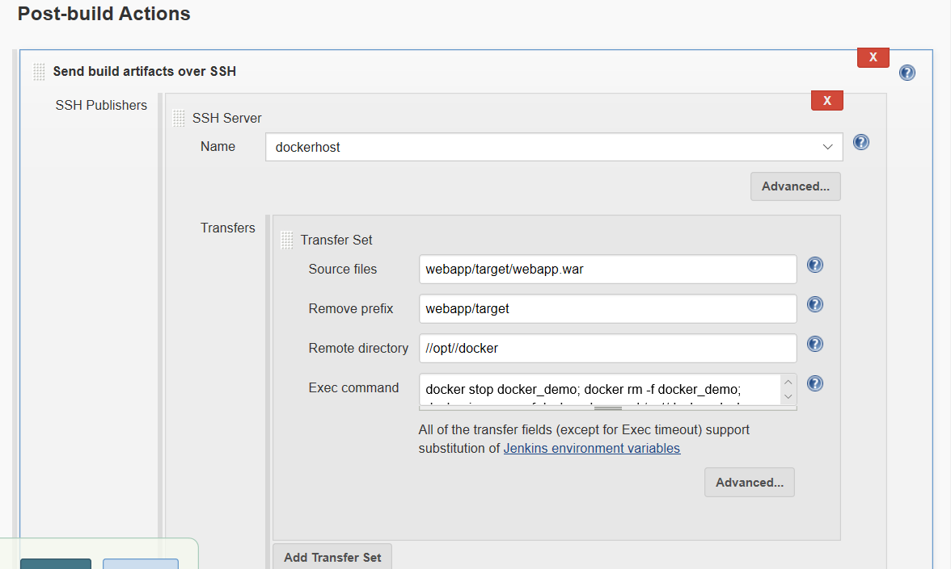

* Pulls the Code from Git
* Builds the Package using Maven

docker stop docker_demo; docker rm -f docker_demo; cd /opt/docker; docker build -t docker_demo . ; docker run -d -p 8080:8080 docker_demo

* Now Save the changes made to Jenkins Job and Build the Job
* Jenkins Builds the package and connects to Docker server over SSH and Copies the application package into /opt/docker folder
* Then Jenkins Job triggers the Docker build command to build the Docker image and runs the Docker container

Once Jenkins Job is success

* Got to AWS Console, Copy Public IP address of Docker Server
* Access from browser with
  + http://<DockerServer-PublicIP>:8080/<Application-Name>
* In our case, The URL is
  + http://<DockerServer-PublicIP>:8080/java-tomcat-maven-example

FYI -- Jenkins Workspace in Linux - /var/lib/jenkins/workspace/